Cosmos Training Options
There are a variety of Cosmos training options available depending on your specific use-case.

SlicerDicer (Aggregate Data)
If you are working with SlicerDicer within Cosmos, there are educational videos available through Epic’s “weLearning” portal that will explain how the portal works, how SlicerDicer works, and will assist you in making more advanced queries. You can search for “Cosmos” to find all relevant videos, or see below:

COS100
COS200
COS300
COS310

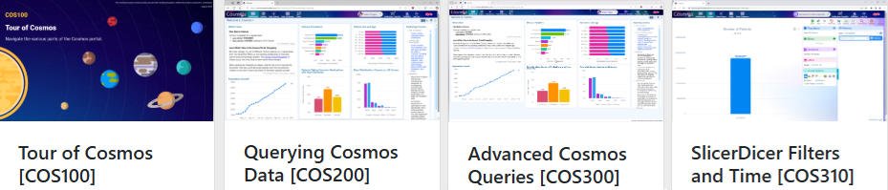

Additionally, we recommend that at least one user per department go through the self-guided training to become a Cosmos Super User – this provides additional training to help become first-level support for Cosmos inquiries within your department, and also grants the organization additional licenses to allow more researchers into Cosmos. To register, email registrations@epic.com letting them know that you’re interested in the “Cosmos Super User Badge”. Once confirmed, they will add it to your account and the materials can be access through Epic’s training site.

Super User training consists of:
- A responsible use self-assessment.
- The four videos outlined above.
- A self-study document with more detailed information about Cosmos.
- A final self-assessment exam.
- A guided project outlining a more complex SlicerDicer use-case.
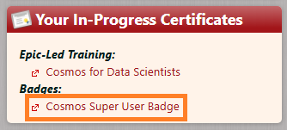

Data Science Virtual Machine (line-level data)
If your work requires access to line-level data or more in-depth analysis than what SlicerDicer will provide, Epic provides the Data Science Virtual Machine (DSVM) – an Epic-hosted virtual machine that provides an advanced set of tools including SQL, Python, R, and Excel. An overview can be found here.

DSVM access is granted by completing an Epic-led training course:
- Data Architect Certification (COS305, $200 + COS500, $600 | $800 total).
The data architect certification (Data Model for Data Architects) provides access to the DSVM and the Expertly Determined De-Identified Data Set (EDDI, the Cosmos database). This data set can be queried at the line-level with two restrictions: county and zip information is removed, and age and other dates are obscured. In addition to SQL access to the full data set, you also gain access to Python, R, and Excel for data analysis or model building, as well as an internal GitLab to share project code.

For the data architect course you must be familiar with SQL and pass two SQL proficiency exams (hosted by Epic, can be taken multiple times) before taking the COS500 class.

Additional Tips
A helpful resource to rely on, both for SlicerDicer work and DSVM work, is the Data Dictionary. This can be accessed through the book-icon at the top of Cosmos and allows you to search for specific pieces of data you are interested in to see if/where it’s available. For example, if you wanted data on encounters within Epic, you might search “encounter” and find the “EncounterFact” table. Once clicked on, you will then be able to see all data contained in this table, whether it’s available in the DSVM, SlicerDicer, or both, the quality/completeness of that data, and a description.

