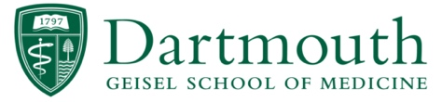
Research Readiness Requirements
for Geisel Students

The following tasks must be completed, and documentation received by Geisel Student Affairs, for you to be credentialed to work on a research project with a Dartmouth Health or Dartmouth College mentor. All of these certificates are to be kept in the Geisel Documents Repository in the Office of Medical Student Affairs.

Item | Method
Felony Attestation | AMCAS Application
National Criminal Background Check | Certiphi
HIPAA Compliance Training | Via Medical Student Affairs Office
BLS Certification | AHA, Military, or the American Red Cross
Drug Screening | Dartmouth Health Occupational Medicine or LabCorp
Human Subjects Research Training | CITI
Health Policy Attestations | Via Medical Student Affairs Office

Once all of these tasks have been completed, the Geisel Student Repository Verification Form (included on this page) must be completed and signed off by Taryn Weinstein or delegate in the Office of Medical Student Affairs.

Once the Geisel Student Repository Verification Form has been signed off, there is no further action that needs to be completed if you are performing non-DH research.

If you are performing research at DH, you must complete the following DH access form on-line. https://forms.monday.com/forms/bc58b72209586aa87f537ad7dfc51beb?r=use1 This form will allow you to have EPIC computer access and be entered into the DH human resources system. You must upload your Geisel Student Repository Verification Form to have access to perform DH research. It will take a about a week to get credentialed to DH once this form is submitted and you will be contacted via email by the DH Workforce Readiness Institute when you are fully credentialed.

Your research mentor will need to add you to the study’s IRB protocol. This will be with the Dartmouth College CPHS (Committee for the Protection of Human Subjects) and/or the Dartmouth Health IRB (Dartmouth-Hitchcock Institutional Review Board).

Research On-Boarding for Geisel Students

Desire to Perform Research at Geisel or DH

Complete all research readiness requirements via the Medical Student Affairs Office

Identify and establish project with Primary Investigator
geiselmed.dartmouth.edu/research/projects

Have your research requirements verified by Taryn Weinstein or delegate in the medical student affairs office and obtain a signed copy of the Geisel Student Repository Verification Form

DHMC Research
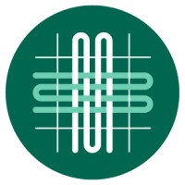

Geisel Research
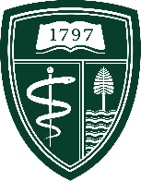

Complete DH Access Form online to obtain DH computer access and entry into the DHMC human resources system
https://forms.monday.com/forms/bc58b72209586aa87f537ad7dfc51beb?r=use1

Dartmouth College Research
Make sure included on Dartmouth CPHS Study Plan (via PI)
www.dartmouth.edu/cphs

Make sure included on DH IRB Study Plan (via PI)
www.dartmouth-hitchcock.org/research/hrpp-irb

Begin Geisel Research!!!

Begin DHMC Research!!!

