1: Statement of Educational Philosophy

This should be 1 to 2 pages of your approach to education. For today, perhaps try to outline a few ideas:

An overarching framework:
An early experience with education:
1.

2.

3.

A story about an ideal educator:
1.

2.

3.

Something you seek to achieve in your teaching:
1.

2.

3.

Any other ways to get started/ideas to include:
1.

2.

2: Amount and diversity of teaching at all levels (Activity tables followed by evaluation tables, followed by narrative)

UNDERGRADUATE EDUCATION (College)
DATES | INSTITUTION | NAME OF COURSE/ACTIVITY | ROLE | FREQUENCY | HOURS

UNDERGRADUATE MEDICAL EDUCATION (MD/DO students)
DATES | INSTITUTION | NAME OF COURSE/ACTIVITY | ROLE | FREQUENCY | HOURS

GRADUATE EDUCATION (MS, MPH, PhD)
DATES | INSTITUTION | NAME OF COURSE/ACTIVITY | ROLE | FREQUENCY | HOURS

GRADUATE MEDICAL EDUCATION (resident/fellow)
DATES | INSTITUTION | NAME OF COURSE/ACTIVITY | ROLE | FREQUENCY | HOURS

CONTINUING MEDICAL EDUCATION:
DATES | INSTITUTION | NAME OF COURSE/ACTIVITY | ROLE | FREQUENCY | HOURS

INTERPROFESSIONAL EDUCATION:
DATES | INSTITUTION | NAME OF COURSE/ACTIVITY | ROLE | FREQUENCY | HOURS
Space for narrative reflection on above activities.

Section B: Quality of teaching in above activities (Tables followed by narrative for each section)

EXAMPLES
1. Evaluations of Medical Student clinical education, July 2012 to present
These are the results of student evaluations of my clinical supervision/teaching in the clerkship course since AY 2012-2013.

 | AY 12-13 | AY 13-14 | AY 14-15 | AY 15-16
global | 4.14 | 4.70 | 4.76 | 4.30
clinical role model | 4.14 | 4.40 | 4.53 | 4.20
clinical supervisor | 4.14 | 4.50 | 4.71 | 4.50
teacher | 4.29 | 4.78 | 4.88 | 4.60
mentor | 4.29 | 4.80 | 4.76 | 4.40

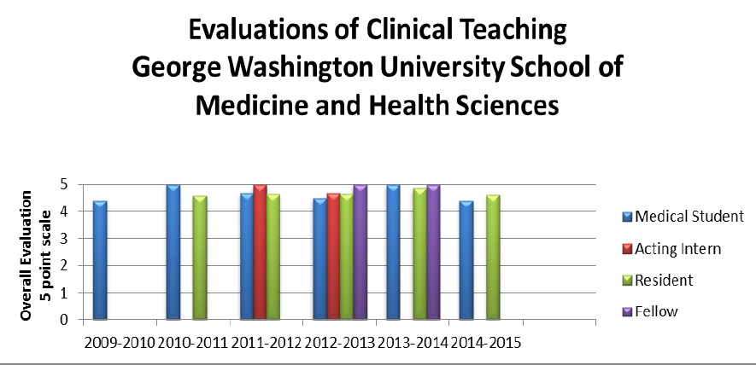

In the space below, lay out tables, graphs, or other ways you could set up how to display evaluation data:

Space for narrative reflection on above activities

3: Curriculum Development: Could be ones you have developed already, or ones you are working on or thinking about now

Use GNOME: Goal/Need/Objectives/Methods/Evaluation

- Title and brief description:

Goal:

Need:

Objectives:

Methods:

Evaluation:

- Title and brief description:

Goal:

Need:

Objectives:

Methods:

Evaluation:

4: Mentoring and Advising

UNDERGRADUATE STUDENTS
DATES | STUDENT/SCHOOL | MY ROLE | DESCRIPTION | CURRENT ROLE

GRADUATE STUDENTS
DATES | STUDENT/SCHOOL | MY ROLE | DESCRIPTION | CURRENT ROLE

MEDICAL STUDENTS
DATES | STUDENT/SCHOOL | MY ROLE | DESCRIPTION | CURRENT ROLE

RESIDENTS AND FELLOWS
DATES | STUDENT/HOSPITAL | MY ROLE | DESCRIPTION | CURRENT ROLE

FACULTY MEMBERS
DATES | FACULTY/SCHOOL | MY ROLE | DESCRIPTION | CURRENT ROLE

Space for narrative reflection on mentoring and advising activities:

5: Products of Educational Scholarship

Publications related to education (e.g. peer reviewed manuscripts, MedEdPortal) and impact (e.g. impact factor of manuscripts, number of downloads from on-line publications)

1.

2.

3.

4.

Workshops (regionally, nationally, and internationally—with %accepted) and peer-reviewed or invited presentations on educational topics. * indicates individual invitation to present, # indicates submitted content chosen by peer review or other organizational process, ^ indicates CME was applicable

DATE | TOPIC/TITLE | ORGANIZATION | LOCATION

Medical Education Grants:
- Title:

Funding agency:

Dates of Award:

Funding Amount:

Role (PI, co-I):

- Title:

Funding agency:

Dates of Award:

Funding Amount:

Role (PI, co-I):

Other educational scholarship products (online curricula, products for boards, study guides, national society education materials)

1.

2.

3.

6: Educational Administration

INSTITUTIONAL
DATES | POSITION | COMMITTEE OR GROUP | INVOLVEMENT AND RESULTS

NATIONAL/INTERNATIONAL
DATES | POSITION | COMMITTEE OR GROUP | INVOVLEMENT AND RESULTS

Space for narrative reflection:

7: Teaching Honors and Awards

AWARD | DATE | SPONSORING ORGANIZATION | AWARD CRITERIA

Narrative reflection on Honors and Awards:

8: Continuing Professional Development in Education

INSTITUTIONAL
PROGRAM NAME AND DESCRIPTION | DATES AND DURATION: | SPONSOR: ORGANIZATION OR INSTITUTION

Space for narrative reflection on continuing development as an educator:

