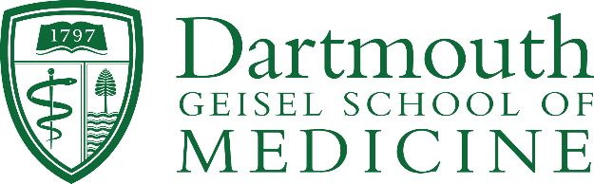

Celebrating Randy Noelle’s Impact
Supporting Trainees in the Department of Microbiology and Immunology
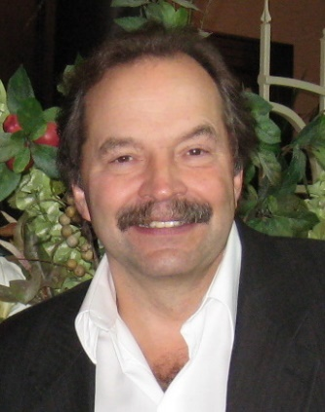
March 2024

Dr. Randy Noelle’s career as a cellular and molecular immunologist and biotechnology entrepreneur has been incredible. In over 30 years at Geisel, he worked to develop novel immunotherapies for autoimmune disease and cancer, and he helped bring those treatments to market. In addition to his research and entrepreneurial work, Randy has been a valued colleague and mentor. He has made a profound impact on his students, the Dartmouth community, and the wider biotech landscape.

“Randy has had a remarkable career, not only as a scientist, but also as a dedicated mentor to so many. The extraordinary legacy of his work is seen in his achievements, and in the incredible achievement of his trainees. His irrepressible energy, enthusiasm, and optimism also make him a special colleague that all of us at Dartmouth will miss upon his retirement.”
– David Leib, PhD, Chair, Department of Microbiology and Immunology

In celebration of Randy’s retirement, friends and colleagues are creating The Randolph J. Noelle, PhD Trainee Research Gift Account to support trainees in the Department of Microbiology and Immunology as they pursue cutting edge, innovative, and translational research experiences at Dartmouth and other affiliated research institutions.

We invite you to join us in celebrating Randy’s impact and legacy by making a gift of any amount to The Randolph J. Noelle, PhD Trainee Research Gift Account.

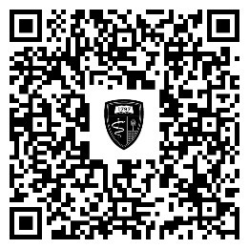
Gifts can be made online or by check. In the “Fund and/or additional gift instructions” field, please include “The Randolph J. Noelle, PhD Trainee Gift Account.”

Medical & Healthcare Advancement
Dartmouth Health / Geisel School of Medicine at Dartmouth
One Medical Center Drive (HB 7070)
Lebanon, NH 03756

For more information, contact:
Jen Herrmann, Regional Director of Development
Dartmouth Health and Geisel School of Medicine at Dartmouth
Jennifer.J.Herrmann@Hitchcock.org | (407) 416-4466

