Dartmouth Geisel School of Medicine
Urban Health Scholars Trip Report
New Orleans, Spring 2018
The Dartmouth Medical School Urban Health Scholars had a wonderful time exploring New Orleans over our week-long spring break. During the week, we shadowed Dr. Solet, alum of Dartmouth Medical School, participated in direct service, and learned about the needs of underserved patient communities in NOLA and how we as future physicians can best serve the urban underserved. We also explored the deep culture and history of the city.
- Laura Cheng

Agrowtopia (March 12, 2018)
By: Roberto De La Rosa

On Monday morning the group met with Mark Quinn who helps lead Agrowtopia. Agrowtopia is an organization within Xavier University that runs an urban farm with the intention of providing fresh produce options to urban communities with limited access to healthy foods or patients that live within food deserts. They accomplish this by selling the produce at a reduced price to the New Orleans community. While speaking with Mark about the organization we discussed how crucial it is for physicians to be aware of barriers to healthy food access in underserved urban areas for their patients, and how helpful it is for physicians to be aware of organizations like Agrowtopia to have a resource to connect their patients with and promote a positive nutrition for their health. Additionally, our group offered the idea for the organization to reach out to physicians in their community to serve as an advocate for the organization and their patients. After speaking with Mark, our group was able to volunteer to help pull weeds and level out soil to help with work needed to maintain the farm.
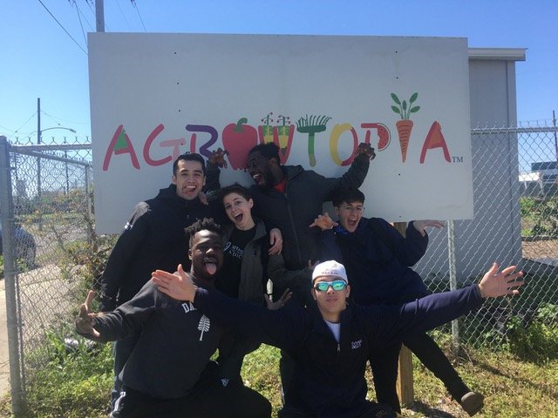

Unity (March 13, 2018)
By: Jay Bader
On Tuesday, March 13th, the Dartmouth Urban Health Scholars visited Unity, a non-profit organization who helps give donated material goods to the homeless population of New Orleans. The Urban Health Scholars received a warm greeting from Kelli and Joe, two of the staff at the Unity Warehouse who help organize and distribute the massive amounts of donated material for the homeless and poor populations of New Orleans. Joe explained that much of the donated material is given to the recently homeless who are now just starting to get a home. Unity also helps connect the homeless with small apartments scattered throughout New Orleans – Joe explained that Unity takes whatever apartments they can find as it can be hard to work with landlords to find homes for the homeless. As the recently homeless move into their new homes, things such as old bed sheets, household cleaners, dishes, and even a few items of clothing can be very valuable to many of the new residents: many of which arrive with nothing but the shirt on their back. That afternoon, the Dartmouth Urban Health Scholars took on the huge task of organizing the mounds of donated goods so that these items could be more easily found and accessed. As Sha dug through and folded piles of donated clothes, Jaci and Sand repaired a broken desk, Roberto and Laura organized dishes, and Kenny and Jay sorted dozens of boxes of bed sheets, pillows, and blankets. By the end of the 2 hour visit, the Unity Warehouse had been organized and cleaned up quite a bit. Kelli and Joe were very grateful for the help as our group working together were able to make a lot of progress on a project that would have taken days for Kelli and Joe to do alone. Reflecting back on the experience, the Urban Health Scholars were touched by the generosity of the New Orleans population to donate so many things to help those who are less fortunate. Furthermore, the dedication that Joe and Kelli had to helping the homeless was very inspirational as it takes people like them to coordinate all the donations to those who need them!
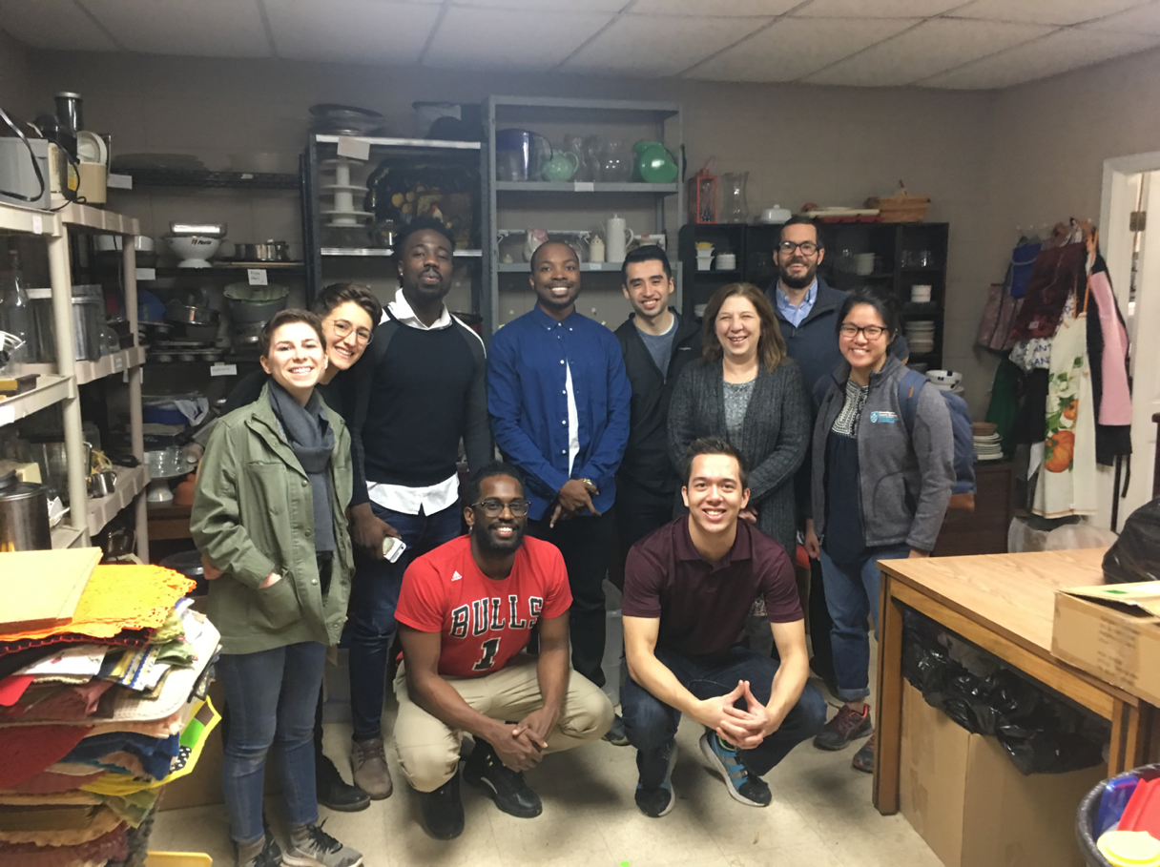
New Orleans Department of Public Health (March 13, 2018)
By: Kenny Williams
On Tuesday afternoon the UHS group visited the New Orleans Department of Public Health where we had the privilege of hearing from Dr. Rochelle Head-Dunham, Dr. Torrie Harris, and Rha'Keisha Wyre. Dr. Head-Dunham started by giving us some insight into her path to medicine as well as her current role as the Director of the Metropolitan Human Services District. She then discussed the struggles of delivering mental and behavioral services to those that need it the most. We got to ask questions and hear about the interplay of the social determinants of health in the mental and behavioral health field. Lastly, she provided some words of wisdom for our medical school journey. Next, Dr. Harris spoke with us about some of the data surrounding health and healthcare in Orleans parish in addition to all the programs currently under the Dept. Of Public Health umbrella. She also discussed some of the changes made by the Public Health Dept. especially regarding oversights of clinics and the new plan for allocation of funds. Dr. Harris concluded with how public health intersects with the delivery of healthcare and how we can engage as we become healthcare professionals. We concluded with Ms. Wyre who gave us the background and history of the Healthcare for the Homeless Clinic. She was able to give us much needed context regarding the growing homelessness epidemic and how the clinic is working to respond. Before we departed, we were able to tour the building and see the medical facilities as well as the dental facilities. We truly appreciated the time and candor that our presenters shared with us. It really helped to give some context to the trip and our work while in NOLA.

Urban Build (March 14, 2018)
By: Sha Ali
Our Urbanbuild experience was interesting because we got to see students, not much different from us, who were implementing their academic project of building homes in a community that had been devastated by the storm. It was interesting to speak to the students because we learned that although there are many organizations that are seeking to rebuild, not all of them are seeking to bring back the natives of the area. Urbanbuild on one hand is creating opportunities for community development by putting up modern property in areas where blight has brought down home values and thus enticing new businesses to the area potentially creating jobs and opportunities. On the other hand the people who can afford to buy these new properties often do not look like the residents of the community or share in the cultural ties, ultimately perpetuating gentrification trends that have been a polarizing issue for some natives. A few of us challenged the students to think about how they could be conduits for a paradigm shift as future architects and invest their time and skills in making homes for those displaced and to think about how that could increase the overall wellbeing of those who were most impacted by the tragedy.
I think as a learning experience it was very good to see the other side of the coin because it gives us an idea where the opportunities for impact exist and allows us to put into context how New Orleans and potentially similar cities can benefit from the forward-thinking of young professionals in a time where social change is critical and is best mobilized by those who will live through its affects decades from now

Xavier College Pre-Med Table (March 14, 2018)
By: Sha Ali
Tabling at Xavier University was an interesting experience. While we were indeed able to talk to some students and provide them with insight about being a premed, the MCATs and the medical school application process, I also found it to be very telling of what the concerns of premeds from this region and this demographic is. I noticed that there weren’t swarms of students trying to talk to us and from the anecdotal information that I gathered I believe it was for three main reasons.
Reason number one is that many of the students we interacted with who were in the process of applying for medical school, some of whom had acceptances in hand, either were going through early assurance programs and were given the option by other schools to forgo the MCAT which they feel was pivotal in their decision. Dartmouth, to those students who are aware of the school’s reputation, also seemed like a reach. Complicated by the fact that medical school’s in bigger more diverse cities make those concessions makes it tough for Dartmouth to truly compete for students.
Reason number two was that many of the students, having been exposed to an environment where most of their classmates looked like them and were typically from underrepresented groups, felt trepidation in coming up to Dartmouth, not only a rural environment far away from home for them, but also a place with a dearth of people they feel they can instantly relate to and find agency with. The fear of dealing with microagressions has been a theme when I spoke to some students. This seemed to be a major driver in people not really strongly considering Geisel as an option.
The third and probably most crucial reason is financial aid. Money is an always will be an issue. Schools that find a way to give underrepresented minorities good aid packages will find more and more of these students at their doorstep. If Dartmouth wants to recruit students of color from places like XULA they must be willing to show that with aid dollars. Until then, other schools who just do a better job of it will be more appealing. Definitely got a sense from the pre-med advisors office that we were not necessarily “the big show” in town, and my intuition was that the combination of these factors played a role.
All in all, we did have some great conversations with some amazing students and we were able to get them to believe that no matter the obstacles they see before them, medical school is a realistic goal for them and one they should vehemently pursue if they find it to be a calling. We gave out contact information and hope to hear from anyone who has more questions or is seeking mentorship.

Tulane University Medical Center (March 14, 2018)
By: Roberto De La Rosa
On Wednesday afternoon a portion of the group met with Dr. Gugel at University Medical Center to talk about his career, healthcare in New Orleans, and get a tour of the new facility. Dr. Gugel is a physician boarded in internal medicine and pediatrics. He completed his residency training at Charity Hospital, and recently transitioned from working at Tulane Community Health Clinic (TCHC) to Tulane University Medical Center. This transition was prompted by a flood that occurred at TCHC which led to the closure of the clinic. During our discussion, we talked about the challenges he was met with as a physician working at TCHC with patients from urban underserved communities. We came to discuss what resources should be set in place at a Federally Qualified Health Center (FQHC) to provide a holistic approach to healthcare for these vulnerable populations. He was able to offer advice by stressing the importance of ensuring proper funding and strong community-engaged physician leadership to advocate for optimizing patient health. Additionally, Dr. Gugel also talked to us about the debate that transpired after Katrina as to what to do with Charity Hospital. Charity Hospital was a major public hospital of New Orleans that served many patients of low socioeconomic status that was adversely affected by Katrina. Afterwards, the hospital was abandoned, never reopened, and eventually University Medical Center, a new institution that cost over a billion dollars to construct, was built nearby. This discussion led to Dr. Gugel stressing the influence that the government has in deciding how money is allocated and healthcare is delivered to the communities of a city. Overall, Dr. Gugel was able to offer his honest perspective as a physician in New Orleans and provide challenges and realities to think about as a prospective physician with a desire to practice in an urban environment.
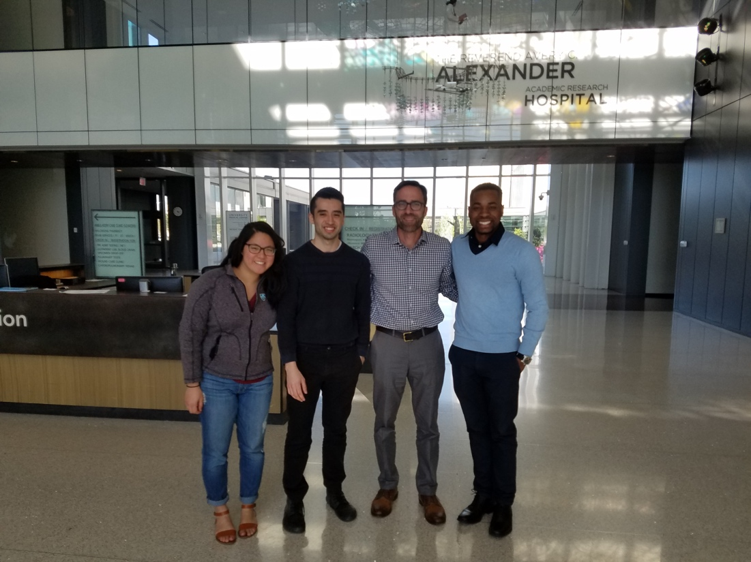

New Orleans Mission Outreach – 3/15/18 and 3/16/18
By: Jay Bader
On Thursday, March 15th, the Dartmouth Urban Health Scholars visited the New Orleans Mission, a non-profit organization who provides food, shelter, and clothing to the city’s homeless, hurting, and hungry. The Urban Scholars began by loading pallets of donated food into massive trucks. The scope of donated food ranged from crackers and bread to fresh vegetables, fruit, and everything in between. Accompanied by a few other volunteers, the Urban Health Scholars drove in a van to a very poor neighborhood in an area of New Orleans that seemed to still be facing the after-effects of Katrina. Upon arrival, the Urban Scholars set up tables around the truck and spread the food out among the tables for people in the neighborhood to take. After only a few minutes, the tables were packed with hungry people graciously taking the food and bringing it back to their small homes. The Urban Health Scholars worked hard unloading the boxes of food from the truck, distributing the food, and handing out plastic shopping bags for people to put food into. After about an hour, all the food had been taken by an estimated 25 people who would now have food to feed their hungry families. Looking back on the experience, it was very powerful to see the lives of others who are less fortunate than we are. We sometimes take for granted that there will always be food on the table and money to feed our families, but in reality, many people in the poorer areas of New Orleans are unable to get food at all – much of it may be still due to the effects of Katrina, which still seemed to linger in some of the poorer areas.

ReNEW School: Dolores T. Aaron Academy - 3/16/18
By: Sand Mastrangelo
Early Friday morning, the group made its way to ReNEW - Dolores T. Aaron Academy, a K-8 public charter school in the Little Woods neighborhood in New Orleans. After Hurricane Katrina, much of the public education system transitioned to a charter model, which has had significant impact on communities of color and the city at large. Prior to our visit, the Urban Health Scholars critically examined this transition and learned about various perspectives in support of and against this new education model.
When the Urban Health Scholars arrived at 8am, they met the school leader, John Gravier, and spoke with him about the demographic of the student body and staff. After a brief tour of the building, the group headed to the library to reorganize the fiction and nonfiction inventory. One group of Urban Health Scholars placed new labels on books that were donated to the school while another assigned reading levels to books and scanned them into the library catalogue. The librarian was immensely grateful for the help and mentioned the library had been in disarray since the school opening.
After working in the library for a few hours, the group joined a second-grade class to introduce them to physical exam skills and share more about the stories that facilitated their paths to medicine. Students listened attentively while members of the UHS group shared personal experiences that contributed to their career choices and recounted the impact of public education and the importance of mentors.
The second graders were split into five groups and rotated through stations facilitated by one or two Urban Health Scholars. During the stations, students completed a health worksheet where they recorded their resting heart rate, heart rate after one minute of jumping jacks or running in place, heart sounds, and lung sounds/respiratory rate. Students listened to each other’s hearts and lungs and enjoyed having the opportunity to use a stethoscope. There was also a yoga station wherein students were able to meditate and refocus after a long week of standardized testing.
The experience was rewarding and elucidated the challenges associated with growing up in a low-income community. It was important to share backgrounds with students to inspire their choices and expand access to educational and future professional opportunities. The Urban Health Scholars anticipate maintaining a long-term connection to the school during their trip to New Orleans in subsequent years.

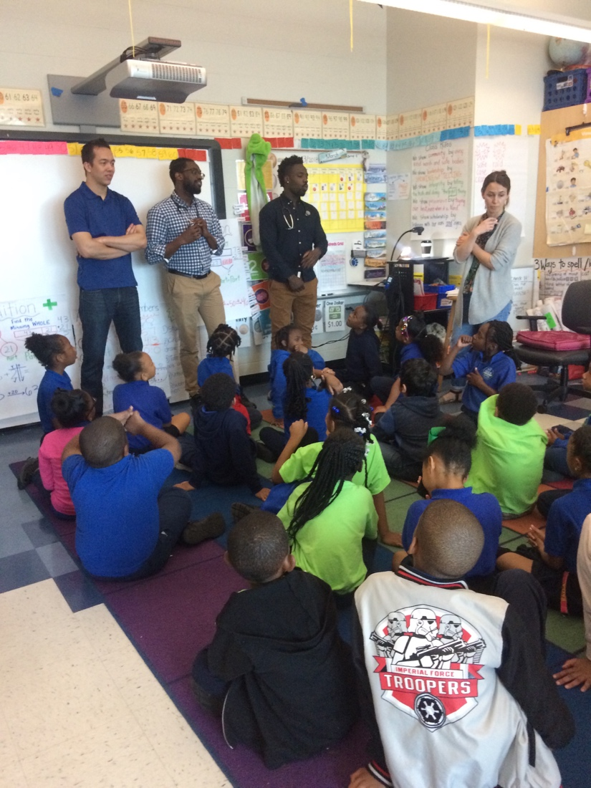

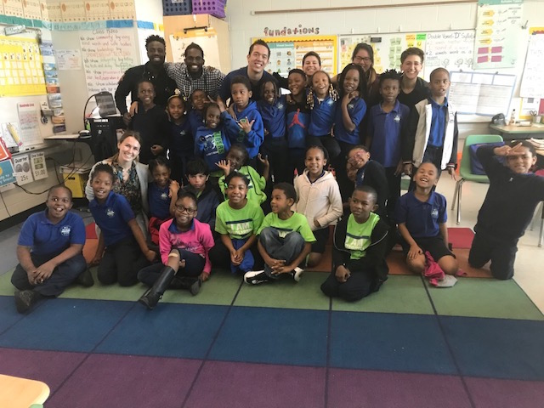

Cardiovascular Institute of the South – 3/12/18 to 3/16/18
By: Jacqueline Gresham

Along with hosting UHS at his home in Schriever, Louisiana, Dr. Solet also graciously facilitated clinical shadowing experiences for each of our members at his workplace, the Cardiovascular Insitute of the South. Each day, 1-2 scholars accompanied Dr. Solet to clinic to consult patients, review images, and participate in procedures.
While each day brought a varied agenda, most of the scholars experienced their very first exposure to cardiac imaging, spending several hours alongside an echocardiogram technician and applying their recently acquired cardiophysiology know-how. Students also accompanied Dr. Solet into his clinical consultations where students were invited to participate in cardiac examinations and to dialogue with patients.
Particularly memorable among the clinic day takeaways were the candid conversations with Dr. Solet outside the examination rooms. Among them were exchanges on navigating interactions with pharmaceutical companies as well as the challenges that have accompanied Medicaid expansion in Louisiana. Our time with Dr. Solet, within the clinic and without, offered opportunities to bring the critical considerations at the forefront of our collective concerns in urban healthcare into a uniquely longitudinal conversation with a provider. For being such an engaging and gracious mentor and host, we are immensely grateful.

